**19.Print the name of the month.**

**Exercise**

* **Ask the user to enter the number of the month & print the name of the month. For eg - For ‘1’ print ‘January’, ‘2’ print ‘February’ & so on**

**Approach:**

**So here we did like this**

**Java : using case switch and take the integer input from the user and print according to the number**

**Python:Same as Java, we’re using Case switch method here, “match-case”.Python 3.10 (2021) introduced the match-case statement which provides a first-class implementation of a "switch" for Python.**

**Solution 👇**

**Java :**

**import java.util.*;**

**public class CodeXam {**

**public static void main(String args[]) {**

**Scanner sc = new Scanner(System.in);**

**System.out.println("Enter the number of the month \n(Press : 1 -12 only) " );**

**int operator = sc.nextInt();**

**String sentence = "The name of the month according to your number is: ";**

**switch(operator) {**

**case 1 : System.out.println(sentence + "January");**

**break;**

**case 2 : System.out.println(sentence + "February");**

**break;**

**case 3 : System.out.println(sentence + "March");**

**break;**

**case 4 : System.out.println(sentence + "April");**

**break;**

**case 5 : System.out.println(sentence + "May");**

**break;**

**case 6 : System.out.println(sentence + "June");**

**break;**

**case 7 : System.out.println(sentence + "July");**

**break;**

**case 8 : System.out.println(sentence + "August");**

**break;**

**case 9 : System.out.println(sentence + "September");**

**break;**

**case 10 : System.out.println(sentence + "October");**

**break;**

**case 11 : System.out.println(sentence + "November");**

**break;**

**case 12 : System.out.println(sentence + "December ");**

**break;**

**default : System.out.println("Invalid Number");**

**}**

**}**

**}**

**output:**

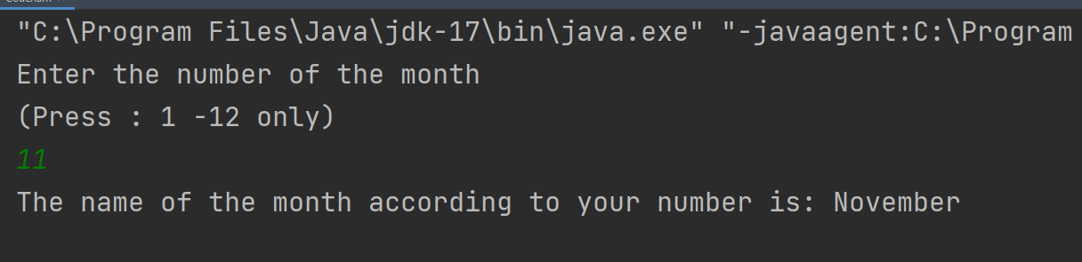

**Python :**

**x = int(input("Please enter the no. of your month: \n"))**

**sentence = "The name of the month according to your number is:"**

**match x:**

**case 1:**

**print(f"{sentence} January")**

**case 2:**

**print(f"{sentence} February")**

**case 3:**

**print(f"{sentence} March")**

**case 4:**

**print(f"{sentence} April")**

**case 5:**

**print(f"{sentence} May")**

**case 6:**

**print(f"{sentence} June")**

**case 7:**

**print(f"{sentence} July")**

**case 8:**

**print(f"{sentence} August")**

**case 9:**

**print(f"{sentence} September")**

**case 10:**

**print(f"{sentence} October")**

**case 11:**

**print(f"{sentence} November")**

**case 12:**

**print(f"{sentence} December")**

**output:**

